**Practical – 1**

1. **Write a program to display student information.**

Code:

a<-"Sujal Vadgama"

b<-"22IT608"

c<-"BVM IT Dept"

cat(a,b,c)

Output :

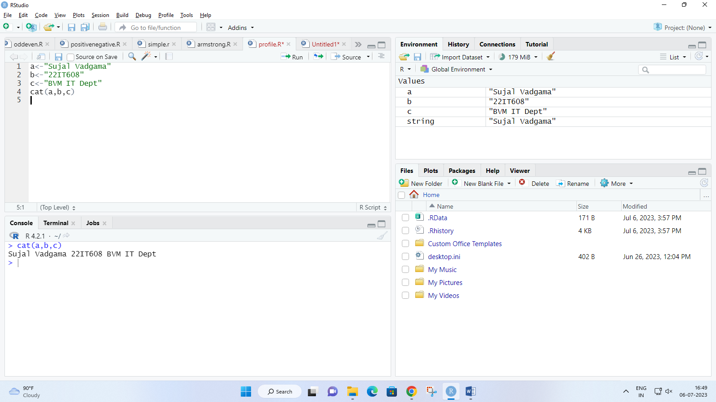

1. **Write a program to find weather a number is even or odd.**

Code:

n <- as.integer(readline(prompt="Enter any number : "))

if(n%%2==0){

print("The entered number is Even!")

}else{

print("The entered number is Odd!")

}

Output:

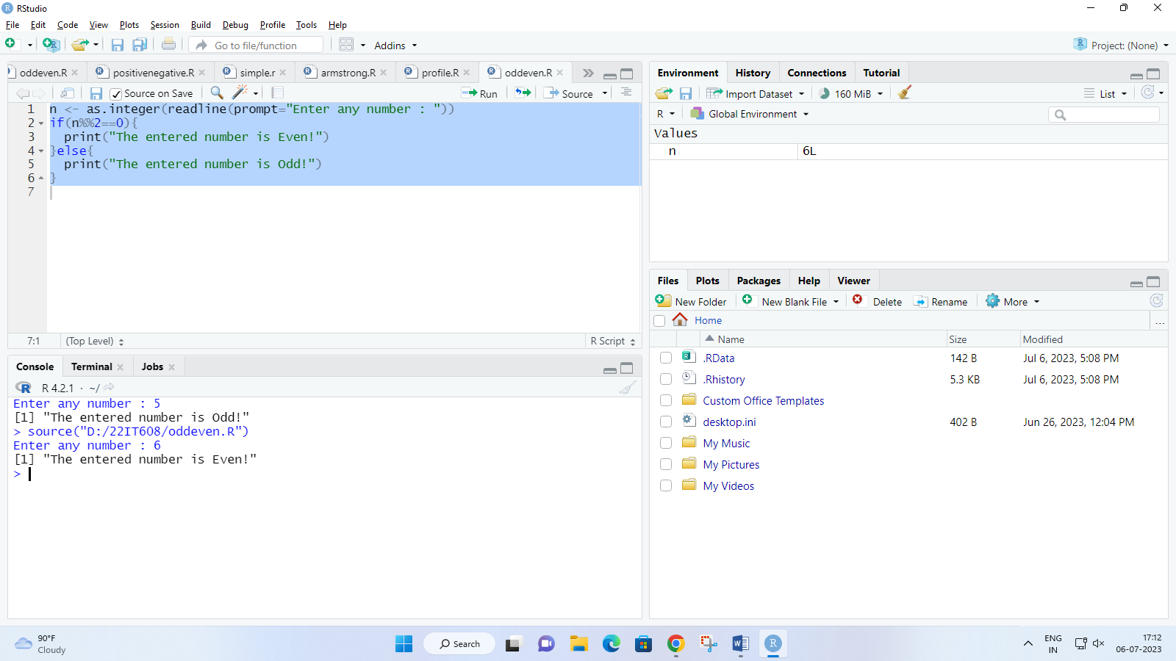

1. **Write a program to create a calculator.**

Code :

a <- as.integer(readline(prompt="Enter 1st Number : "))

b <- as.integer(readline(prompt="Enter 2nd Number : "))

choice <- as.integer(readline(prompt="Enter Choice :\n 1 = Addition\n 2 = Subtraction\n 3 = Multiplication\n 4 = Division\n 5 = Modulo\n "))

switch(choice,

"1"=cat("Addition",a+b),

"2"=cat("Subtraction",a-b),

"3"=cat("Multiplication",a*b),

"4"=cat("Division",a/b),

"5"=cat("Modulo",a+b))

Output :

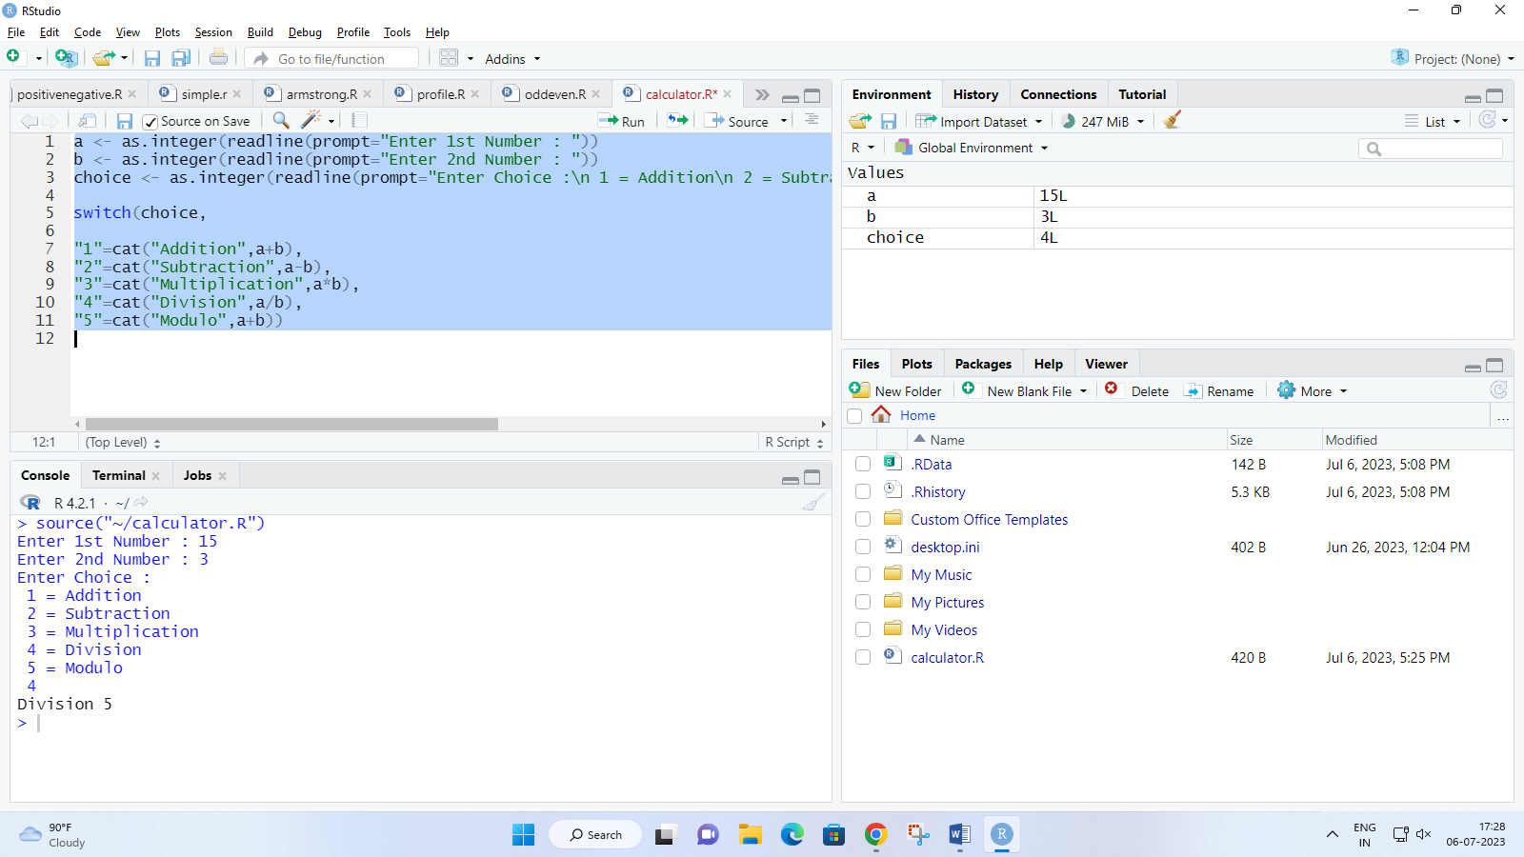

1. Write a program to find greatest of 2 number.

Code :

a <- as.integer(readline(prompt="Enter 1st Number ; "))

b <- as.integer(readline(prompt="Enter 2nd Number ; "))

if(a<b){

cat("The greatest number is",b)

}else{

cat("The greatest number is",a)

}

Output :

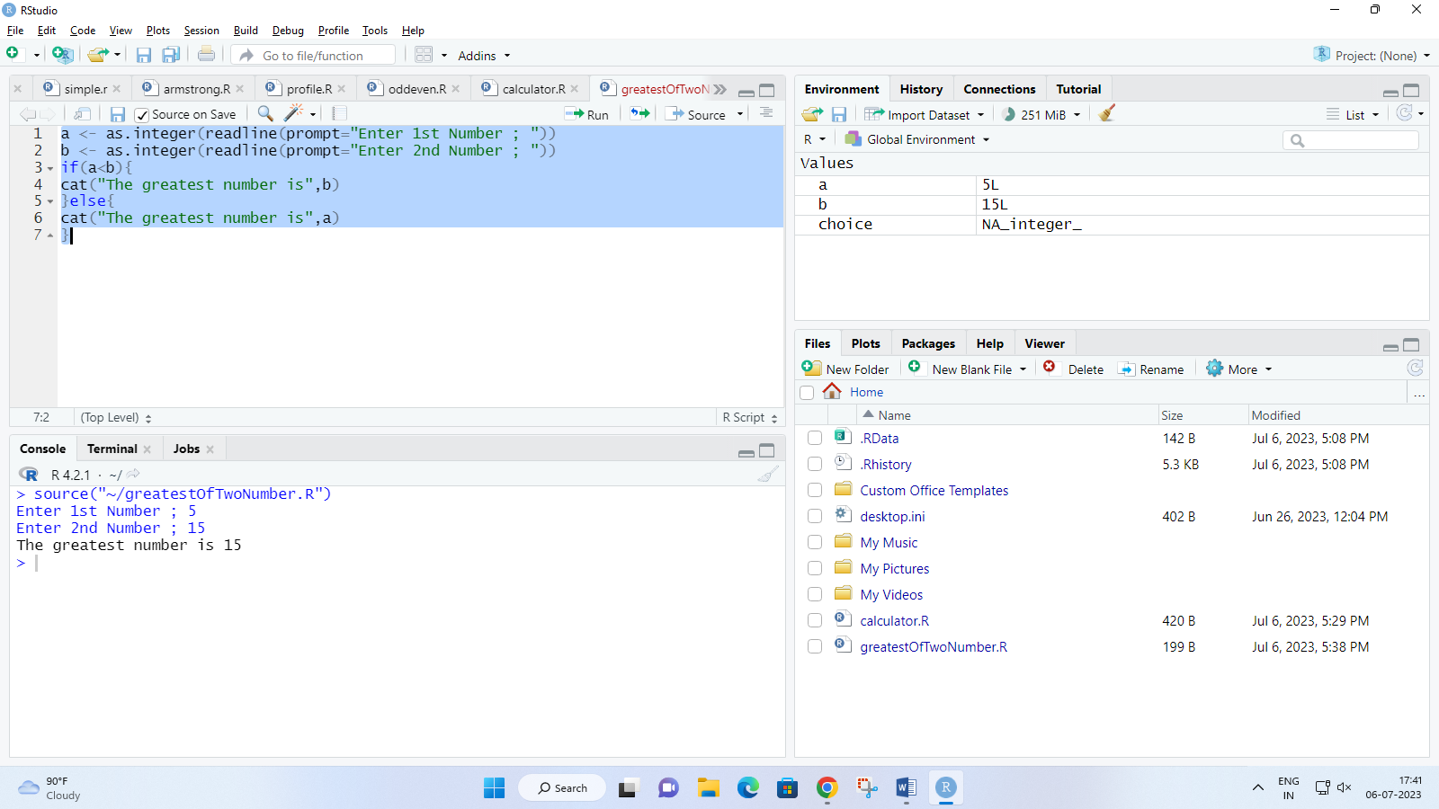

1. Write a program to calculate grade of student with help of marks scored.

Code :

eng <- as.integer(readline(prompt="Enter Marks of English : "))

mat <- as.integer(readline(prompt="Enter Marks of Maths : "))

sci <- as.integer(readline(prompt="Enter Marks of Science : "))

hin <- as.integer(readline(prompt="Enter Marks of Hindi : "))

guj <- as.integer(readline(prompt="Enter Marks of Gujarati : "))

if(eng >100 | mat > 100 | sci > 100 | hin > 100 | guj > 100){

cat("Please enter marks correctly!")

}else{

if(eng > 32){

cat("Please clear English!!!\nGrade : FF")

}else if(mat < 32){

cat("Please clear Maths!!!\nGrade : FF")

}else if(sci < 32){

cat("Please clear Science!!!\nGrade : FF")

}else if(hin < 32){

cat("Please clear Hindi!!!\nGrade : FF")

}else if(guj < 32){

cat("Please clear Gujarati!!!\nGrade : FF")

}else{

total <- eng + mat + sci + hin + guj

avg <- total/5

cat("Total marks scored : ",total,"\n",

"Percentage : ",avg,"%\n")

if(avg<=100 & avg>90){

cat("Grade : AA\n Success! Cleared examination with 1st class Distiction.")

}else if(avg<=90 & avg>=80){

cat("Grade : AB")

}else if(avg<=80 & avg>=70){

cat("Grade : BB")

}else if(avg<=70 & avg>=60){

cat("Grade : BC")

}else if(avg<=60 & avg>=50){

cat("Grade : CC")

}else if(avg<=50 & avg>=40){

cat("Grade : CD")

}else if(avg<=40 & avg>=35){

cat("Grade : DD")

}else if(avg<35){

cat("Grade : FF\n Sorry! Did not clear examination.")

}

}

}

Output :

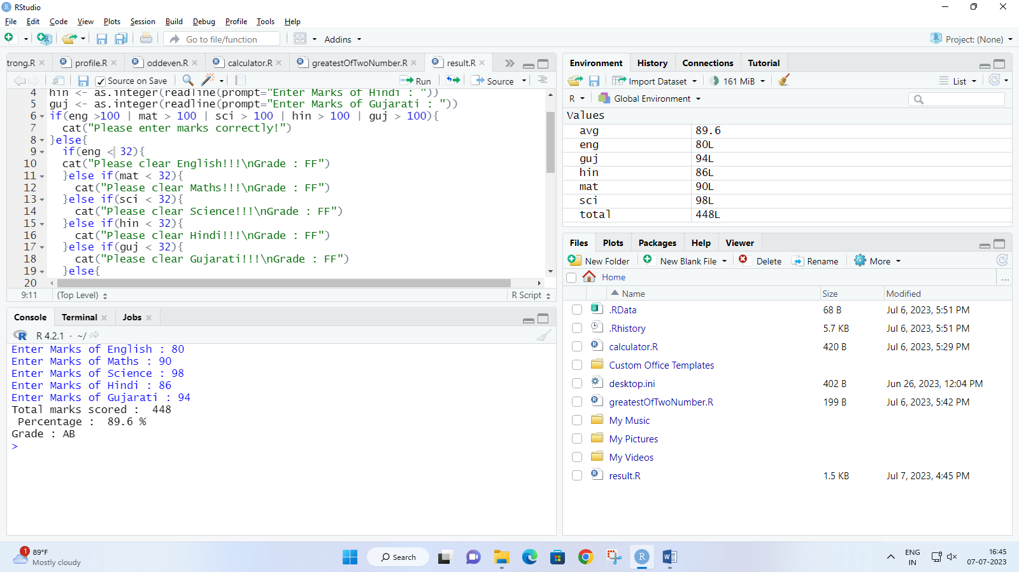

1. Write a program to print Fibonacci series of a entered number

Code :

n <- as.integer(readline(prompt="Enter a Number to print it's fibonacci series : "))

a <- 0

b <- 1

cat(a,b,"")

while(n != 0){

c = a + b

a = b

b = c

n = n-1

cat(c,"")

}

Output :

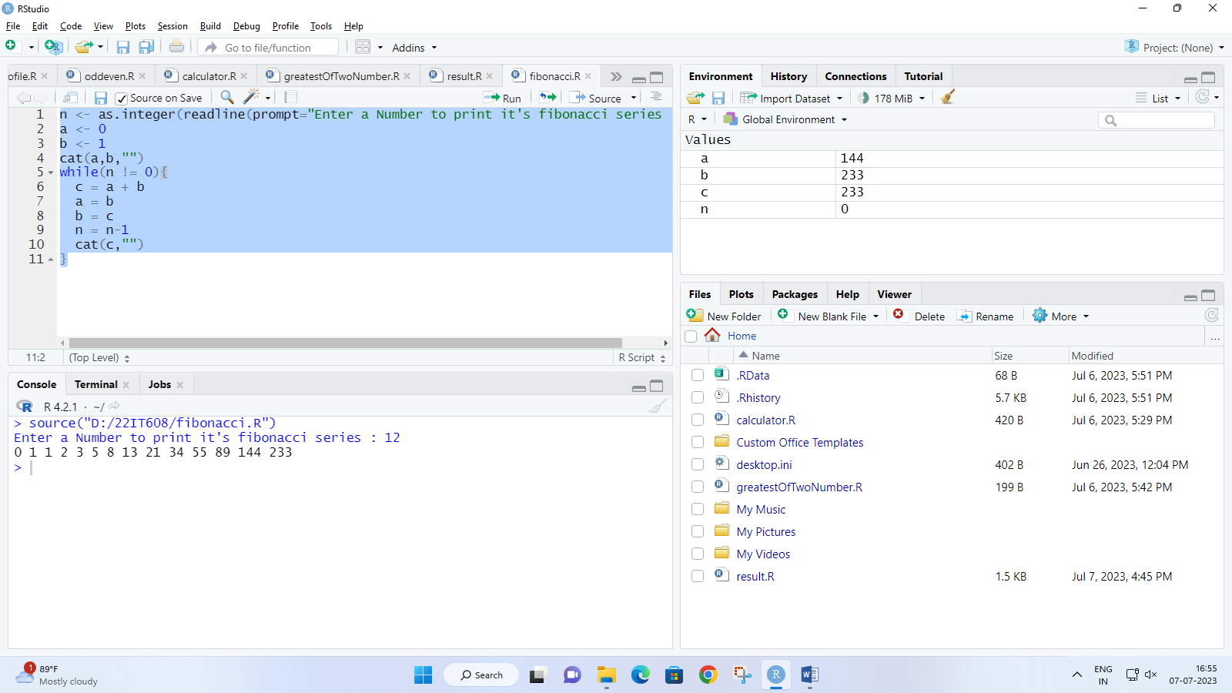

1. Write a program to check weather entred number is palindrome or not.

Code :

n <- as.integer(readline(prompt="Enter a Number : "))

num <- n

rev <- 0L

while(n != 0){

rem = n %% 10

rev = rem + (rev*10)

n = as.integer(n/10)

}

if(num == rev){

cat(num,"is a Palindrome number !")

}else{

cat(num,"is not a Palindrome number !")

}

Output :

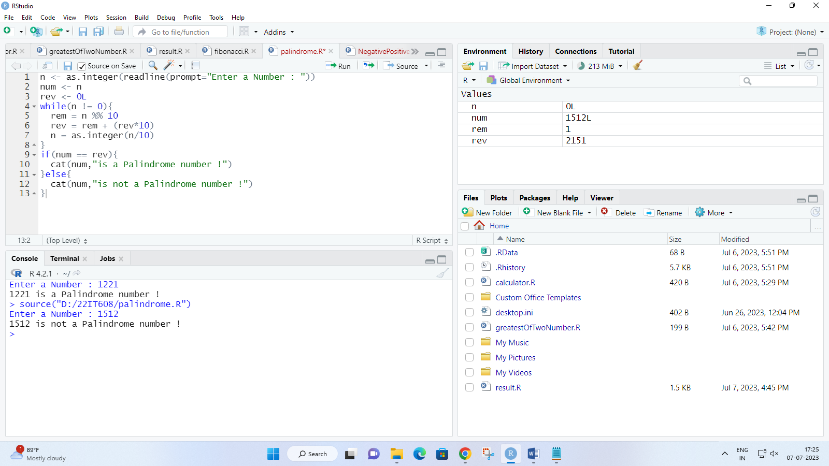

1. Write a program to check weather a entered number is Armstrong or not.

Code :

n <- as.integer(readline(prompt="Enter a Number : "))

org <- n

temp <- n

len <- 0

sum <- 0L

while(temp != 0){

temp <- floor(temp/10)

len <- len+1

}

while(n != 0){

remainder <- (n%%10)

sum <- (sum + (remainder^len))

n <- as.integer(n/10)

}

if(org == sum){

cat("The Number",org,"is Armstrong Number")

}else{

cat("The Number",org,"is not an Armstrong Number")

}

Output :

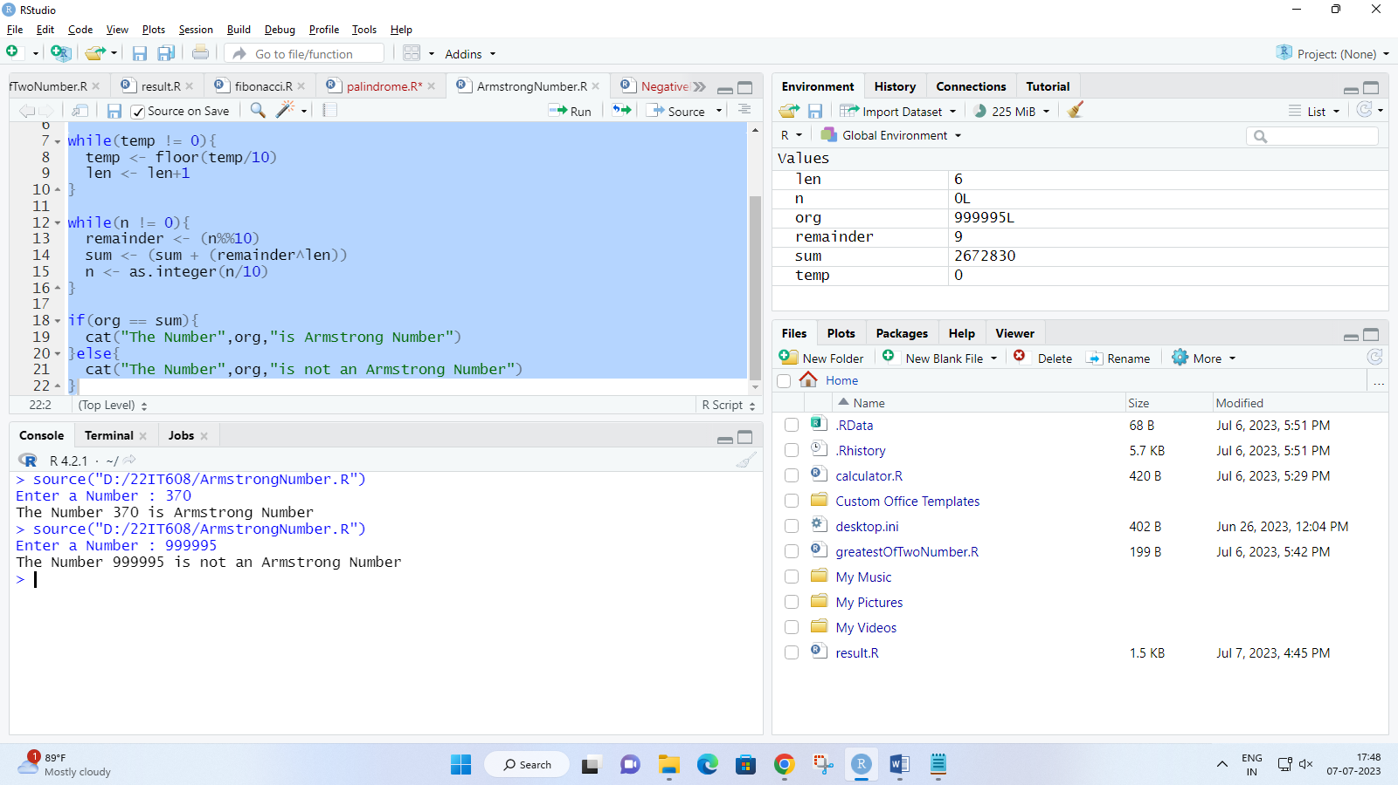

1. Write a program to find factorial of a number (recursion)

Code :

fact <- function(n) {

if(n==0 || n==1)

{

return(1)

} else{

return(n*fact(n-1))

}

}

fac <- as.integer(readline(prompt="Enter a number for factorial : "))

ans<-fact(fac)

cat("Factorial of ",fac," is : ",ans)

Output :

